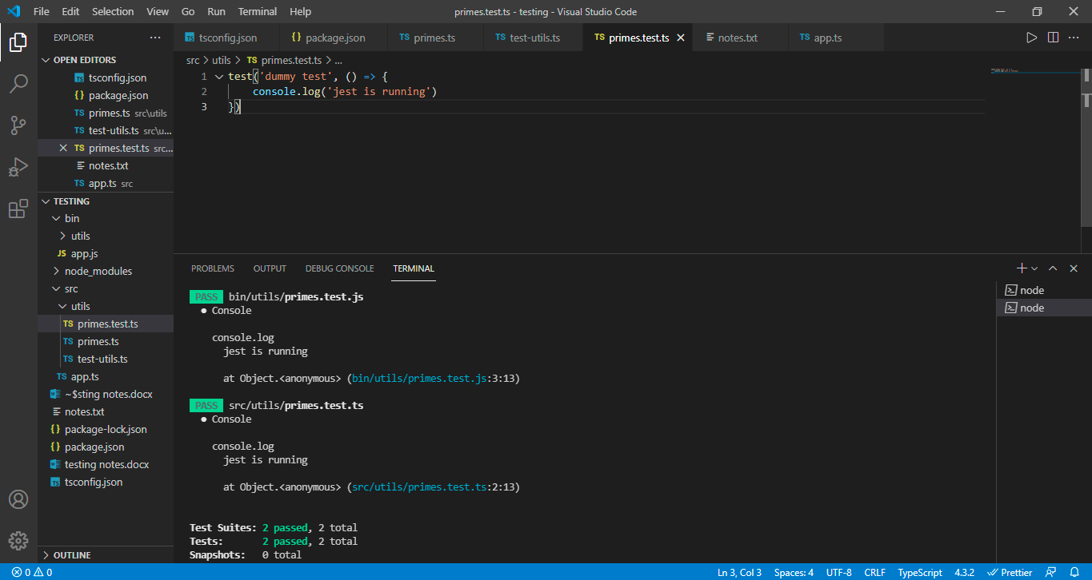

For one test, we are getting 2 passed result bcz, testing is happening in both ts and js files.

To ensure only ts are running install

Npm i -D jest ts-jest @types/jest